**Indira Gandhi Delhi Technical University for Women**

**(Established by Govt. of Delhi vide Act 09 of 2012)**

**(Formerly Indira Gandhi Institute of Technology)**

**Kashmere Gate, Delhi - 110006**



**LABORATORY FILE**

**for**

**Web Technologies**

**MCA 207**

**Submitted by:**

**Submitted to:**

Ms. Ankita Singh Roopal Mittal

MCA, 3rd Sem

02004092019

**Date: 17-09-2020**

**LAB 7 WORK**

**Ques 1: Create BOOK.XML and validate it using BOOK.DTD**

**<mybooks>**

**<book>**

**<bookname></bookname>**

**<bookid></bookid>**

**<bookdescription>**

**</bookdescription>**

**</book>**

**<book>**

**<bookname></bookname>**

**<bookid></bookid>**

**<desc>**

**</desc>**

**</book>**

**</mybooks>**

**XML Code:**

<?xml version="1.0" encoding="UTF-8"?>

<!DOCTYPE mybooks SYSTEM "books.dtd">

<mybooks>

<book>

<bookname>"Web Tech"</bookname>

<bookid>10</bookid>

<bookdescription>Introduction to Web</bookdescription>

</book>

<book>

<bookname>"Basics of HTML/CSS"</bookname>

<bookid>123</bookid>

<bookdescription>New Edition</bookdescription>

</book>

</mybooks>

**DTD Code:**

<?xml version="1.0" encoding="UTF-8"?>

<!ELEMENT mybooks (book+)>

<!ELEMENT book (bookname,bookid*, (bookdescription|desc?))>

<!ELEMENT bookname (#PCDATA)>

<!ELEMENT bookid (#PCDATA)>

<!ELEMENT bookdescription (#PCDATA)>

**Output:**

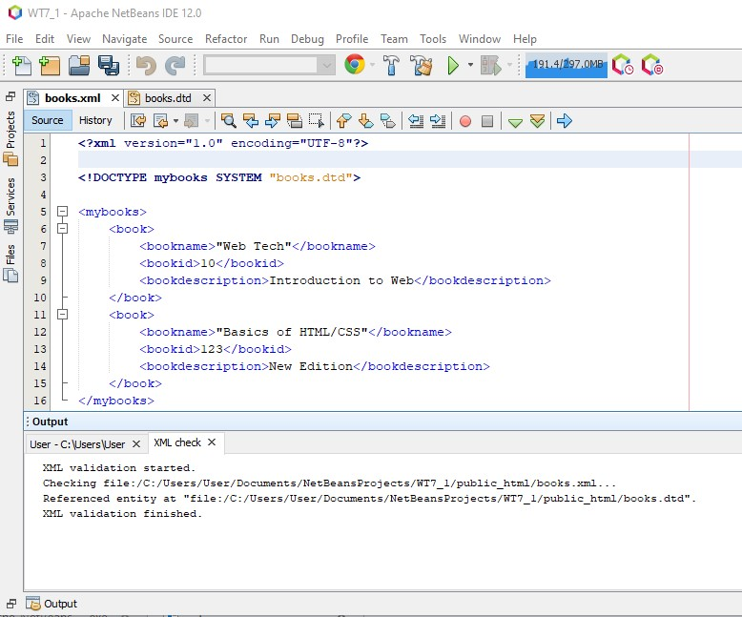

**Ques 2: Create XML of CATALOG.XML and validate using schema. Price range (10-100), all the elements should be in the same order.**

**XML Code:**

<?xml version="1.0" encoding="UTF-8"?>

<catalog xmlns:xsi="http://www.w3.org/2001/XMLSchema-instance" xsi:noNamespaceSchemaLocation="catalog.xsd">

<cd>

<title>Empire Burlesque</title>

<artist>Bob Dylan</artist>

<country>USA</country>

<company>Columbia</company>

<price>10</price>

</cd>

<cd>

<title>Hide your Heart</title>

<artist>Bonnie Carlson</artist>

<country>Bulgaria</country>

<company>London</company>

<price>90</price>

</cd>

<cd>

<title>Pikachu Hits</title>

<artist>Arijit Singh</artist>

<country>India</country>

<company>Crisotta</company>

<price>19</price>

</cd>

</catalog>

**SCHEMA Code:**

<?xml version="1.0"?>

<xs:schema version="1.0"

xmlns:xs="http://www.w3.org/2001/XMLSchema"

elementFormDefault="qualified">

<xs:element name="catalog">

<xs:complexType>

<xs:sequence>

<xs:element ref="cd" minOccurs='1' maxOccurs='unbounded'/>

</xs:sequence>

</xs:complexType>

</xs:element>

<xs:element name="cd">

<xs:complexType>

<xs:sequence>

<xs:element name="title" minOccurs='0' maxOccurs='1' type='xs:string'/>

<xs:element name="artist" minOccurs='0' maxOccurs='1' type='xs:string'/>

<xs:element name="country" minOccurs='0' maxOccurs='1' type='xs:string'/>

<xs:element name="company" minOccurs='0' maxOccurs='1' type='xs:string'/> <xs:element name="price">

<xs:simpleType>

<xs:restriction base="xs:integer">

<xs:minInclusive value="10"/>

<xs:maxInclusive value="100"/>

</xs:restriction>

</xs:simpleType>

</xs:element>

</xs:sequence>

</xs:complexType>

</xs:element>

</xs:schema>

**Output:**

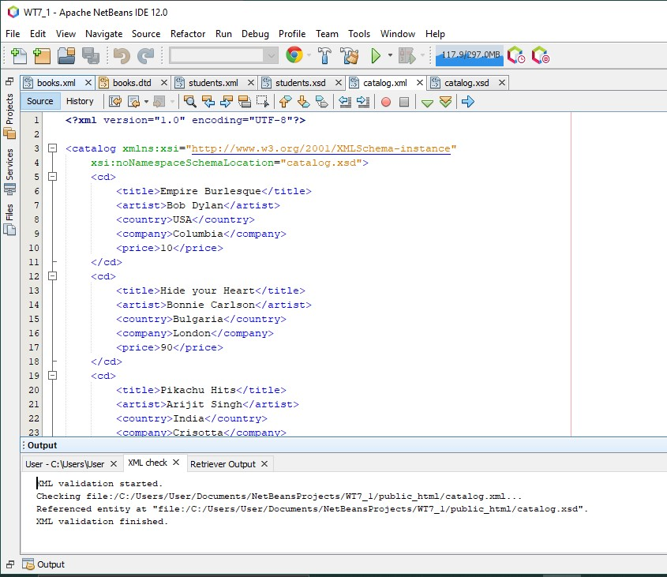

**Ques 3: Create STUDENT.XML (Students (Student (Name, Age, RollNo, Course)) and validate using schema. Restriction on Age (18-25), RollNo (1-70) and numeric value allowed on RollNo and Age. Restriction on course using enumeration (MCA, BTech, MTech)**

**XML Code:**

<?xml version="1.0" encoding="UTF-8"?>

<students xmlns:xsi="http://www.w3.org/2001/XMLSchema-instance" xsi:noNamespaceSchemaLocation="student.xsd">

<student>

<name>Roopal Mittal</name>

<age>21</age>

<rollno>020</rollno>

<course>MCA</course>

</student>

<student>

<name>Pratham Mittal</name>

<age>20</age>

<rollno>043</rollno>

<course>BTech</course>

</student>

<student>

<name>Rishabh</name>

<age>22</age>

<rollno>020</rollno>

<course>Mtech</course>

</student>

</students>

**SCHEMA Code:**

<?xml version="1.0" encoding="UTF-8"?>

<xs:schema version="1.0"

xmlns:xs="http://www.w3.org/2001/XMLSchema" elementFormDefault="qualified">

<xs:element name="students">

<xs:complexType>

<xs:sequence>

<xs:element ref="student" minOccurs='1' maxOccurs='unbounded'/>

</xs:sequence>

</xs:complexType>

</xs:element>

<xs:element name="student">

<xs:complexType>

<xs:sequence>

<xs:element name="name" minOccurs='0' maxOccurs='1' type='xs:string'/>

<xs:element name="rollno">

<xs:simpleType>

<xs:restriction base="xs:integer">

<xs:minInclusive value="1"/>

<xs:maxInclusive value="70"/>

</xs:restriction>

</xs:simpleType>

</xs:element>

<xs:element name="age">

<xs:simpleType>

<xs:restriction base="xs:integer">

<xs:minInclusive value="18"/>

<xs:maxInclusive value="25"/>

</xs:restriction>

</xs:simpleType>

</xs:element>

<xs:element name="course">

<xs:simpleType>

<xs:restriction base="xs:string">

<xs:enumeration value="B.Tech."/>

<xs:enumeration value="M.Tech."/>

<xs:enumeration value="MCA"/>

</xs:restriction>

</xs:simpleType>

</xs:element>

</xs:sequence>

</xs:complexType>

</xs:element>

</xs:schema>

**Output:**

